
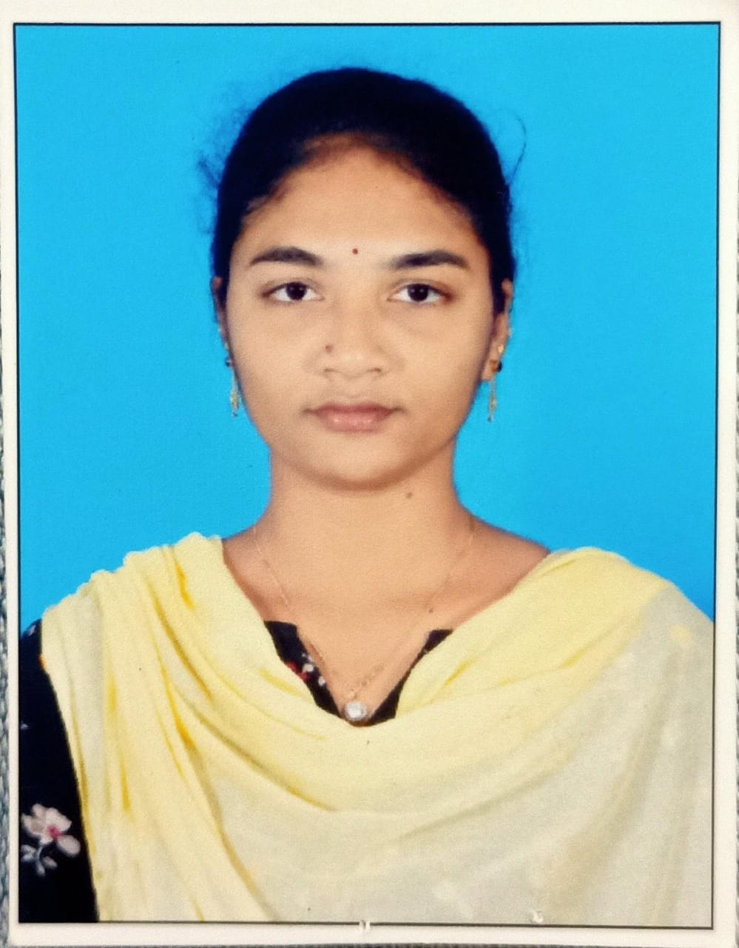

KANKIPATI SANDHYA SRAVANI
PERSONAL PROFILE
sandhyarahal@gmail.com 9392450158
Yanam

EDUCATIONAL
QUALIFICATIONS
2021
DEGREE-B.Voc.TSI
PONDICHERRY UNIVERSITY COMMUNITY COLLEGE
PONDICHERRY
- PONDICHERRY UNIVERSITY
- GPA:75%

2017
INTER - MPC
ANGEL JUNIOR COLLEGE KAKINADA
- Board Of Inter Mediate Education
,AP
- GPA:65%
2013
SSC
MGGOVTBOYSHIGH SCHOOL,YANAM
- Board Of Secondary Education, Ap
- GPA:60%

CAREEROBJECTIVE

Highly-motivated employee with desire to take on new challenges. Strong work ethic, adaptability, and exceptional interpersonal skills. Adept at working effectively unsupervised and quickly mastering new skills.

WORK EXPERIENCE

Worked as a Primary Teacher in Nallam Residential Concept School, Yanam from Oct 2021 to April 2024.

STRENGTHS

- Excellent Communicational And Interpersonal Skills  - Remote office availability  - Communication  - Time management  - Good Telephone Etiquette | - Microsoft office  - Hard working & Result oriented  - DCA  - PGDCA

LANGUAGES

Telugu,English,Tamil,Hindi

DISCLAIMER

I hereby declare that the above-mentioned information is true upto my best knowledge and I bear the responsibility for the correctness of the above-mentioned particulars.

Place:
Date: (K.SANDHYASRAVANI)

.
#HRJ#d2db5e4c-c31c-407a-b392-ff6bdbc5b4d6#

