KABILAN B 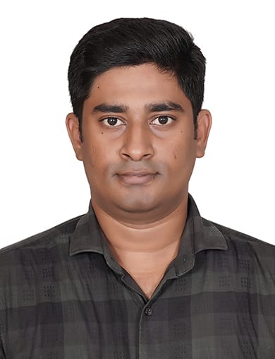
📍 Chennai, Tamil Nadu
📞 8056141642 | 📧 kabilanbala18@gmail.com🔹 Professional Summary
Dynamic professional with a proven track record at Cipla Ltd, excelling in operations management and team leadership. Achieved significant sales growth through strategic planning and exceptional customer relations. Skilled in decision-making and fostering collaboration, consistently enhancing client loyalty and driving business success.
🔹 Work Experience
Assistant Manager
Cipla Ltd, Chennai, India
February 2021 – Present

Roles and Responsibilities
- Updating Therapy to the Doctors By conducting RTM, Conferences, Camps
- Updating the Competitors information on all the Products and Planning. Accordingly to Make conversion
- Stockist Handling for Primary Orders
- Secondary orders follow up on Weekly once
- Maintaining the Doctors as well as Chemist Average as Per organization expectations
- Planning The business and achieving given Target
- Leading the Team in Month End sales Closing as well as Coordinating team in Doctors Engagement
Business Executive
Intas Pharmaceuticals Ltd., Chennai, India
March 2018 – February 2021
Client Relationship Executive
Cordlife Sciences India Pvt. Ltd., Chennai, India
April 2016 – February 2018
Relationship Executive
Cryoviva Biotech Private Limited, Chennai, India
June 2015 – March 2016

🔹 Education
Bachelor of Arts in Commerce
Sindhi College of Arts and Science, Chennai, Tamil Nadu
Graduated: April 2015

🔹 Skills
- Operations Management
- Team Leadership
- Employee Performance Evaluations
- Cost Reduction
- Team Motivation
- Decision-Making
- Customer Relations
- Team Building
- Customer Relationship Management (CRM)

🔹 Languages Known
- Tamil – Native
- English – Fluent
Declaration:

I hereby declare that all the information furnished above is true to the best of my belief.

Place: Chennai Yours Sincerely
Date:

(B. KABILAN)

