**"name": "MGM Book Appt":**

URL: <https://kraniumhims.mgmhealthcare.in/mgm-portal-api/public/api/v1/appointments/book-appointment>

Parameters:

{

    "patient_id":"286646",

    "is_existing_patient": **false**,

    "doctor_id":"100007",

    "department_id":"506",

    "appointment_date_time":"2023-11-29 16:20",

    "appointment_type": "DIRECT_CONSULT",

    "location_id":"90"

}

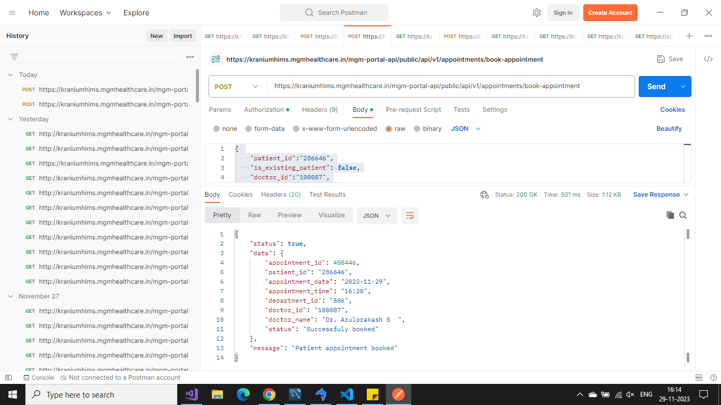

**"name": "MGM Slots":**

**URL:** <https://kraniumhims.mgmhealthcare.in/mgm-portal-api/public/api/v1/appointments/check-availability>

Parameters:

{

    "request_date": "2023-11-30",

    "department_id": "558",

    "doctor_id": "100257",

    "location_id":"90"

}

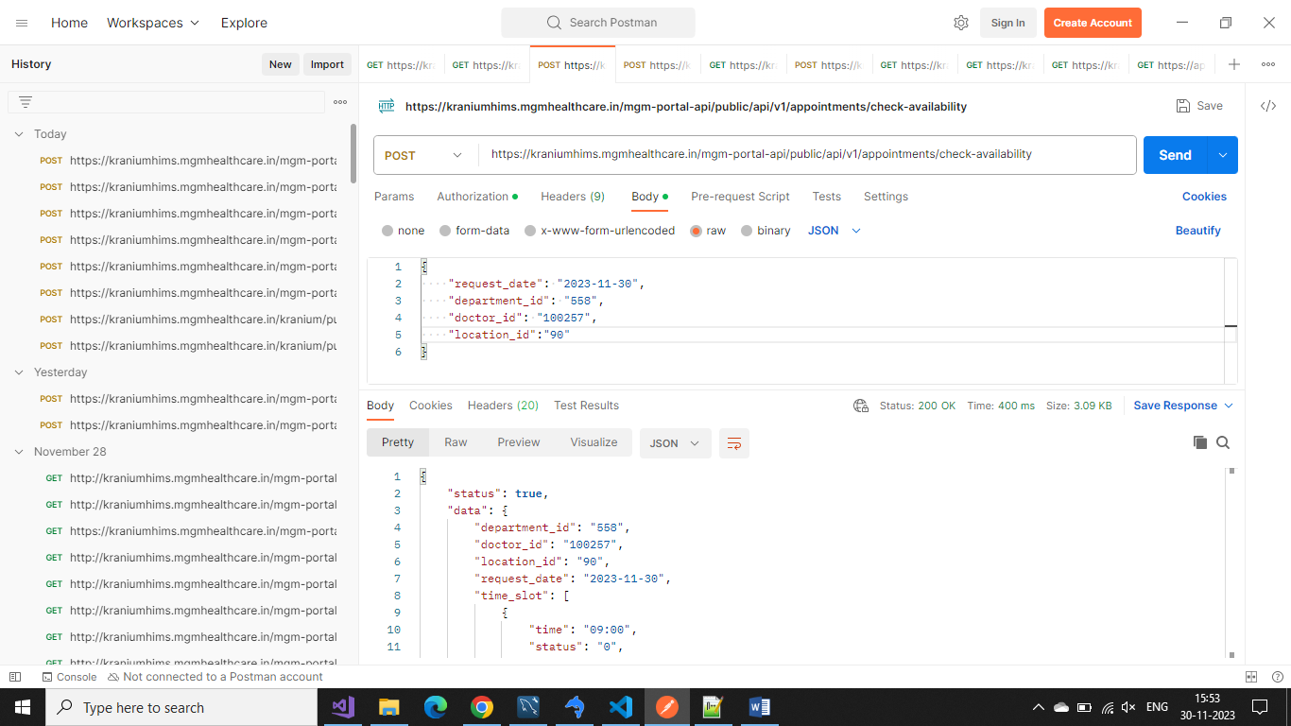

**"name": "Doctor list API Prod":**

**URL:** <https://kraniumhims.mgmhealthcare.in/mgm-portal-api/public/api/v1/personnels/doctors>

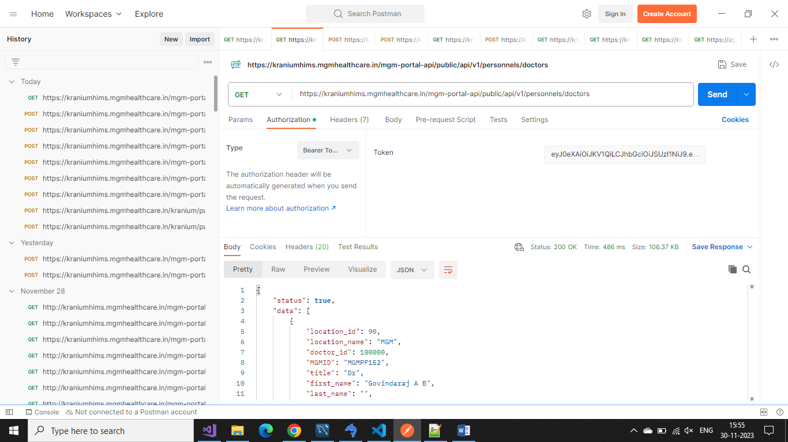

**"name": "Patient List Check":**

**URL:** <https://kraniumhims.mgmhealthcare.in/mgm-portal-api/public/api/v1/patients/7093882026>

Output:

{

    "status": **true**,

    "data": [

        {

            "temporary_id": 251628,

            "Title": "Mr",

            "name_first": "rajeev",

            "name_last": "krishna",

            "address": "vizag",

            "gender": "M",

            "age": 25,

            "cellphone": "7093882026",

            "registered_on": "2021-07-20 16:59:54"

        },

        {

            "temporary_id": 286644,

            "Title": "Mr",

            "name_first": "rajeev",

            "name_last": "krishna",

            "address": "vizag",

            "gender": "M",

            "age": 26,

            "cellphone": "7093882026",

            "registered_on": "2023-02-27 13:56:36"

        }

    ],

    "message": "Patient data list"

}

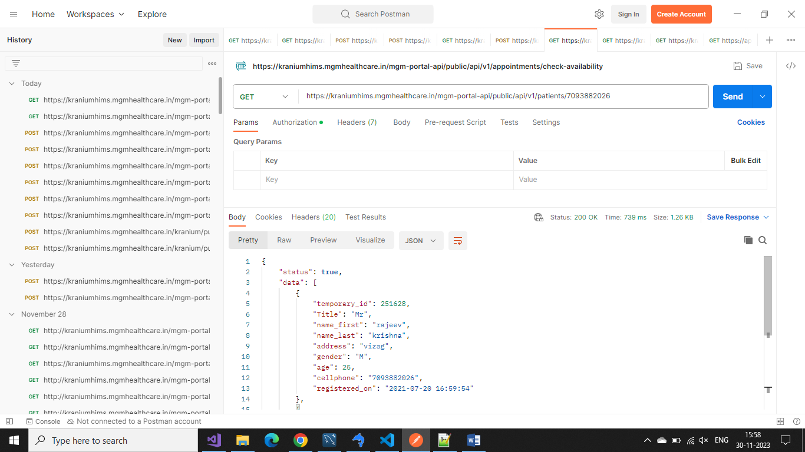

**"name": "Pre Register":**

**URL:** <https://kraniumhims.mgmhealthcare.in/mgm-portal-api/public/api/v1/patients/pre-register>

Method: Post

Request:

{

 "title": "Mr",

 "age": "45",

 "request_from": "CHATBOT",

 "reason":"Consultation",

 "first_name": "Test11",

 "last_name": "Test111",

 "gender": "M",

 "email":"test@gmail.com",

 "mobile": "9750803899",

 "address": "Test"

}

**Output:**

{

    "status": **true**,

    "data": {

        "temporary_id": 306316,

        "msg": "Successfuly added"

    },

    "message": "Patient added"

}