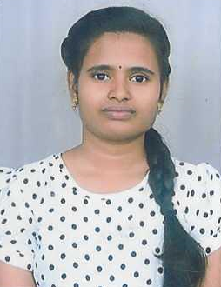

CONTACT
Mob: 8331093326
Email.:bobbasanalini@gmail.com

Address
D.no :71-31-106/19/2
Gudivada Appanna Colony Malkapuram
Visakhapatnam, AP
Pin:530011

Personal Profile
Name : NALINI BOBBASU
Dob :01-02-2003
Marital :unmarried Nationality : Indian Father : Ramana
Mother : Swathi

Languages
- Hindi
- English
- Telugu

Research
A study to assess the Dietary Knowledge among Chronic kidney diseases Patient who have undergone hem dialysis selected hospital, Visakhapatnam

NALINI BOBBASU

Objective
Looking for an objective work In prestigious medical care Organization ,Where I’ll get good exposure for my nursing knowledge and skills, beside getting accustomed with most modern nursing Practices and technologies.

Skills
- Self motivated
- Analytical thinking
- Hardworking
- Empathetic
- Quality Nursing Care
- Effective Communication

Academic Qualification
Graduation
Course : B.Sc Nursing
Institution : St.Ann's college of nursing,
Malkapuram Visakhapatnam
University :Dr.N.T.R University of health Sciences ,Andhra Pradesh Year 2025
Higher Secondary
Board Sri Chaiatanaya Junior College,AP Pradesh 2020
10TH CBSC
Board :Kendriya Vidyalaya No.1,NSB,AP Year 2018

Clinical Experience(2021-2025)
  - St.Ann’s Jubilee Memorial Hospital Visakhapatnam
  - King George Hospital Visakhapatnam
  - Government Hospital for Mental Care Visakhapatnam
  - Government Victoria Hospital Visakhapatnam

Workshop
  - St.Ann's college of Nursing Visakhapatnam ,Development mind culture and maintaining mental health

Reference
Sr. Jaise Mary
Professor of psychiatry(Principal)
St.Ann’s College of Nursing Visakhapatnam Ph no :- 9441375647

Declaration
I here by declare that the above furnished details are correct told the best of my knowledge and belief.

( NALINI B )

