CLINICAL SKILL  - Basic Life Support (BLS)  - Clinical Care Management  - Patient Assessment  - IV Therapy  - Medication Administration  - Wound Care  - Communication  - Team work  - Emergency Care  - End of life Care  LANGUAGES  - Tamil  - English  INTEREST & HOBBIES  - Writing  - Reading  - Explore countries  - Sports (Throwball)  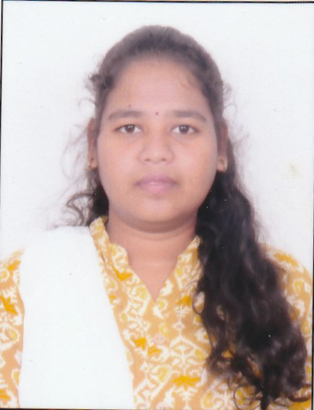 |  | VASANYA . K  STUDENT NURSE
  CONTACT
  8220533523
  kowsivasanya33@gmail.com
  No. 1/111, Main Road Street Thiruvathikunnam Village & Post
  Gingee (TK),
  Villupuram Dist - 604 205
 |  | OBJECTIVE
- To seek a job in your esteemed concern where my skills, talents and knowledge can be utilized at the possible extent.
- To make effective contribution through innovative ideas to develop better solution for the growth of the concern.

 |  | CERTIFICATIONS AND ACHIVEMENT
- Certificate on labor skill
- Certificate on yoga for nursing professionals
- Certificate on 5th conference on Genetic and genomic frontiers in pediatric health care - emerging technology and break through to practice "
- Certificate on state level e-poster and quiz competition for World diabetes day - SNA unit by Venkateshwara Nursing College.
- Certificate on state level online quiz competition for Tamilnadu state AIDS Control Society by Red Ribbon Club across the state
- Attended demo class on Basic life support.
- Attended webinar on SNAI E conference -TNAI Tamilnadu state branch.
- Attended Bi-webinar on Our Nurses! Our Leader! Our Icon
- Attended webinar on IV therapy challenges and solutions - Infusion Nurses Society –INDIA
- Certificate on Access to “ Diabetes Care”
- Certificate on “ JAM season 7”
- Certificate on “ Diabetes and Wellbeing”

 |  | EDUCATION
 |  | Bachelor of Nursing  Venkateswara Nursing College,  Thalambur, Chennai | 2022-2026

PERSONAL DATA
DATE OF BIRTH : 12-10-2003
AGE : 22
GENDER : female
MARITAL STATUS : single
NATIONALITY : Indian
RELIGION : Hindu
FATHER’S NAME : Krishnan S
MOTHER’S NAME : Vijayakumari K
SSLC REG NO : XM19R0896652693
HSC REG NO : 2016563434
B.SC (N) REG NO : 660021523055

EDUCATIONAL CREDENTIALS

Qualification | Name of the Institution | Year of Passing | Percentage (%)
B.Sc Nursing | Venkateswara Nursing College, Thalambur, Chennai. | 2026 | 1 Year – 73 %  II year – 81 %  III year – 87%  IV year – 82 %
HSC | Chanakya Matriculation Higher Secondary School, Gingee | 2021 | 88 %
SSLC | St. Micheal’s Matriculation Higher Secondary School, Gingee. | 2019 | 85 %

CLINICAL EXPERIENCE
SPECIALITY AREA | INSTITUTION | PLACE
NURSING FOUNDATION | Government Hospital | Tambaram
MEDICAL SURGICAL NURSING-I | Government Hospital | Tambaram
MEDICAL SURGICAL NURSING-I | Annai Arul Hospital | Mudichur
COMMUNITY HEALTH NURSING -I | Vels Venkateswara Health Centre | Thalambur
MENTAL HEALTH NURSING | Institute of Mental Health | Kilpauk
MEDICAL SURGICAL NURSING-II (Neuro,Onco,Eye,ENT Specialities) | Gleneagles Health City | Perumbakkam
CHILD HEALTH NURSING | Kanchi Kamakoti CHILDS Trust Hospital | Nungambakkam
CHILD HEALTH NURSING | Neolife Children’s Hospital | Velachery & Madipakkam
URBAN COMMUNITY HEALTH NURSING | Government Hospital | Tambaram
RURAL COMMUNITY HEALTH NURSING | Primary Health Centre  Sub Centre | Kelambakam  Pudhupakkam
MIDWIFERY AND OBSTETRICAL NURSING | Government Hospital | Tambaram

INTERNSHIP
SPECIALITY AREA | INSTITUTION | PLACE
MIDWIFERY AND OBSTETRICAL NURSING, COMMUNITY HEALTH NURSING | Government Hospital | Tambaram
MEDICAL SURGICAL NURSING, MENTAL HEALTH NURSING, CHILD HEALTH NURSING | VELS Medical College and Hospital | Periyapalayam

DECLARATION
I declare that all the statement mentioned above is real & true to best of my knowledge & belief. I am also confident of my ability to work in a team.

Yours faithfully,
VASANYA. K

