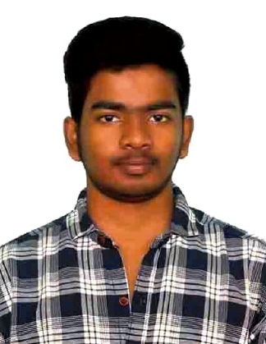

CAREER OBJECTIVE

KEWIN D
Chennai, India 600069
9840302384
Kewindominicsavio@gmail.com

To secure a responsible career opportunity in your esteemed organization where my knowledge can be shared and enriched. I would like an opportunity to contribute effectively for the growth of this organization.

EDUCATIONAL QUALIFICATION
Government Higher Secondary School, Somangalam, chennai , 2019
SSLC
- 55.4

Government Higher Secondary School ,Somangalam , Chennai 2021
HSC
  - 67.5

Dr. MGR Educational and Research Institute, Chennai, TN, 2021-2025

B.Sc.(N) I Year

TRAINING UNDERGONE
- Government Maternal and Child Health Special Care Centre, Thiruvallur.
- Urban Primary Health Center, Nerkundram, Chennai.
- Rural Primary Health Center, Nayapakkam, Chennai.
- Dr. Fernandez Home for Schizophrenia, Mugalivakkam, Chennai.
- Kanchi Kamakoti Childs Trust Hospital, Nungambakkam, Chennai.
- ACS Medical College and Hospital, Velappanchavadi, Chennai.
- Sri Lalithambigai medical collage & hospital maduravoyal, Chennai.
• National Leprosy screening survey [2025]. Chennai Government survey
• Thaimoogambigai Dental College. Chennai

CONFERENCES/WEBINA R ATTENDED
- National conference-[NURTURE 2023] Integrating Health Literacy Challenges and Strategies.
- Kalaignar Centenary International Medical Conference –“FUTURE OF MEDICINE”
- Saveetha Medical college – 2nd health sciences research submit
- Virtual Nursing Conference [2024]

PROJECTS
- Study To Assess The Adjustment Problems And Coping Strategies Among 1st Year B.Sc Nursing Students Of Dr. MGR Educational And Research Institute Of Faculty Of Nursing

COMPUTER KNOWLEDGE
- Sound knowledge of MS office
- Power Point
- Excel spreadsheet
- Basic computer knowledge

LANGUAGES
Tamil: First Language

English:
Proficient

C2 Hindi: C2

Proficient

SKILLS
- Interpersonal skillls
- Critical Thinking
- Computer Literate
- Problem Solving
- Communication Skills

PERSONAL DETAILS
- Father's Name : Dominic savio. M
- Date of birth : 17.01.2004
- Sex : Male
- Nationality : Indian
- Martial Status : Unmarried
- Permanent Address: 5\456A, Sakthi nager, 4th cross street, Poondhalam ,Chennai-69
- Email Id : Kewindominicsavio@gmail.com
- Hobby : Outdoor, Indoor game and Art and craft etc

DECLARATION
- I, Mr. Kewin.D hereby submit these Curriculum Vitae for your kind consideration and for favorable orders. I assure you, if I am selected, I will discharge my duties to the entire satisfaction of my superiors. I declare that the information furnished above is true to the best of my knowledge.

[KEWIN.D]

REFERENCE

Dr. Hema. V H, Principal
Dr M.G.R Educational and Research Institute, Contact Number : 9444383220

Prof. Parameshwari. M, Vice Principal
Dr M.G.R Educational and Research Institute, Contact Number : 8973212022

