B SUNITHA  Mobile: +91 7358506712 | Email: sunithas997@gmail.com  Laboratory Sciences • Medical Genetics • Administration | 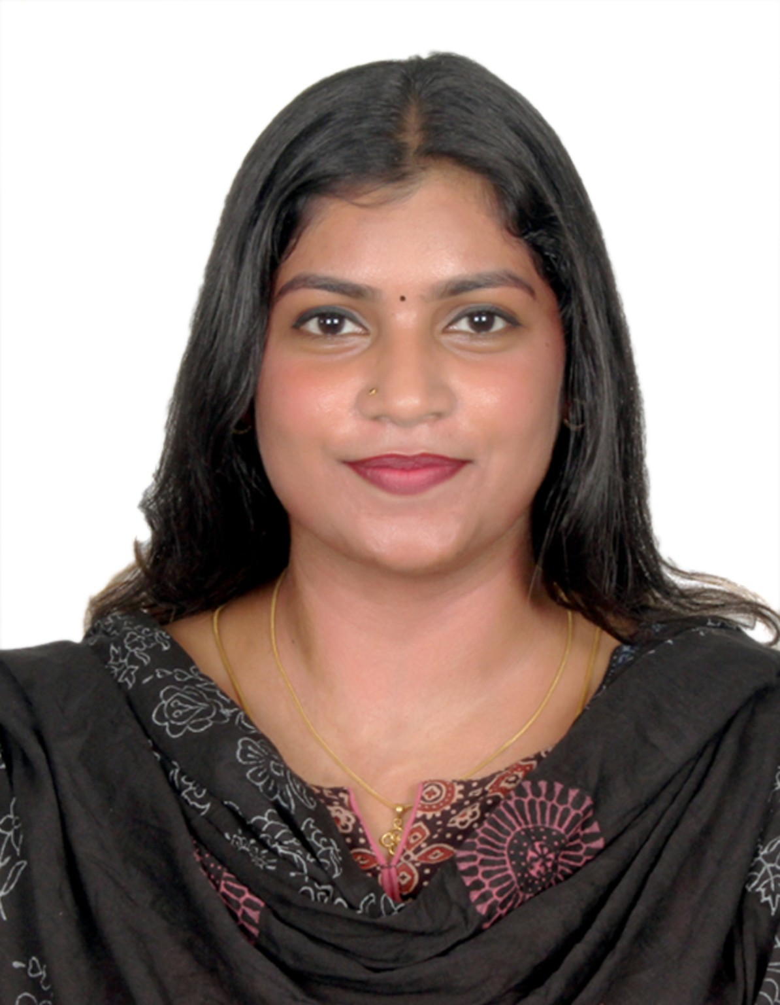
OBJECTIVE
To obtain a position for continuous leaning and growth in the field of laboratory sciences.
EDUCATION
PGDMLT — First Class
Indira Gandi Technological and Medical Sciences University | 2021–2022
B.Sc Zoology — Second Class
J.B.A.S College, University of Madras, Chennai, Tamil Nadu, India | 2011–2014
Higher Secondary (Bio-Math) — First Class
St. Ebbas Girls Hr. Sec School, RK Salai, Chennai, Tamil Nadu, India | 2009–2011
Secondary — First Class
St. Ebbas Girls Hr. Sec School, RK Salai, Chennai, Tamil Nadu, India | 2009
WORK EXPERIENCE
Senior Secretary — Department of Medical Genetics, Apollo Main Hospitals, Chennai - 600006
Dec 2019 – Apr 2026
- Answer telephones, receive and route messages, documents and direct to appropriate technical staff.
- To be aware of IT med mantra usage and applications; receive samples by med mantra, follow up missing samples and coordinate repeat samples.
- Maintain third copy of report, master register soft copy, stock register soft copy and other reports soft copy through SharePoint.
- Prepare monthly log sheets, sterility testing co-ordination and other communications from lab.
- Calculate and tally test volumes and TAT; prepare data for quality monitors to check delayed reports, repeat sample, error reports and culture failure due to lab confounding factors.
- Assist in document and maintenance of all quality registers/documents and clerical documentation.
- Print, scan and save soft copy of other reports for correlation of Cytogenetic reports.
- Dispatch reports by email, post and through riders appropriately; receive phone calls and forward to technical team as required.
- Check departmental mails and elevate to next levels; maintain reception area.
- Check completion of test request, consent and file up.
- Maintain IT validation document for cytogenetics to avoid discrepancy on updating of Hospital Information System.
- Training and departmental meeting co-ordination.
- Prepare inventory data for Lab stores, Housekeeping, Pharmacy and Stationery.
- Maintain confidentiality of genetic reports in chromosomal analysis; postnatal and prenatal reports are kept as re-reported.
- Draw pedigree in master register; maintain documents in OneDrive for data backup.
- Receive molecular (in-house & outsource) samples, scan relevant documents and send to genomic mail.
- Dispatch DNA sample and TRFs to AHLL riders; prepare NGS QC checklist for DNA sample.
- Coordinate with outside vendors regarding binding, request forms, seal and letter head.
- Participated in internal and external audit (NABL, JCIA, ISO).
Admin & Front Office Executive — Sarvesh Pharmacy, Royapettah High Road, Chennai
Jan 2016 – Apr 2017
- Management of accounts, payment to suppliers, preparation of invoice for exporting medicines, weekly proceeds, management of transactions and consignments from customers and pharmaceuticals from reception till delivery.
Tele Sales Executive — New Star Leisure Concept Private Limited, RK Salai, Chennai
Nov 2014 – May 2015
- Customer care and liaison for MGM membership cards
CONTINUOUS PROFESSIONAL DEVELOPMENT
- Help to Organized CME on Fragile X Syndrome in Boat House, Adyar Chennai dated 21 April 2024.
- Help to Organized two days’ workshop titled: “Hands-on Workshop on KARYOTYPING, FISH & M-FISH” in our Medical Genetics department dated 2nd August & 3rd August 2024.
- Attended & certified “POSH at workplace” learning program conducted by Apollo Hospitals dated October 2024.
- Secretarial work for preparing documents for Rare Disease awareness day RACE FOR 7 – 23-Feb-2025.
- Help to Organized two days’ workshop titled: “Hands-on Workshop on KARYOTYPING, FISH & M-FISH” in our Medical Genetics department dated 2nd August & 3rd August 2025.
OTHER KEY SKILLS
Conversant in handling MS Word, Excel, PowerPoint.
PERSONAL DETAILS
Spouse Name: Parthiban P
Gender: Female
Date of Birth: 20-May-1994
Marital Status: Married
Languages Known: Proficient in English and Tamil
REFERENCES
- Dr N Indhumathi Ph.D — Head & Geneticist, Department of Medical Genetics, Apollo Main Hospitals, Chennai, India | Mobile: +91-8754403488 | Mail: geneindhuyahoo.com
- Mr Senthil — Proprietor, Sarvesh Pharmacy, Royapettah High Road, Chennai | Mobile: +91-9840386615
COMMUNICATION / PERMANENT ADDRESS
E-17 “X” Block (OPP) P.M Nagar, Mylapore, Chennai - 600 004
Alternate Phone No: 9941045768
I hereby declare that the above given information’s are true to the best of knowledge.
Hope to work with you.
Sign with date.

